Contents

Section 1 – Technical Merit 2

Purpose 2

GitHub 2

Folder Contents 2

Extras implementations 3

Lessons Learned 4

Difficulties 4

Section 2 - Diagrams 4

Use case 5

Class Diagram 5

Presentation Layer 5

Data Access Layer 6

Business Logic Layer 6

Sequence Diagram 7

Insert Student 7

Delete Student 7

Update Student 7

Insert User 8

Delete User 8

Student Grid 8

Section 3 - Database Script 9

# Section 1 – Technical Merit

## Purpose

This software was created using the requirements from the CA. As the document outlined, we need to build a 3-tier application to develop a student management system for DBS.

The idea is applying what was learnt throughout the software development course, how to proper use concepts such as:

* Object Oriented Programming: classes, hierarchy and emuns.
* Database Design and Development: create tables and user storage procedures.
* Information System and Development: UML Diagrams.
* Advanced programming: multitier architecture, delegates, regular expressions, data manipulation, GitHub.

In order to access the system, you can use username *paul* and password *paul* or username *admin* and password *admin*.

## GitHub

The GitHub repository link is: https://github.com/Bruno-dos-Santos/202002-CA over there you will find all folders and its files used during the CA, such as source codes, documentation, diagrams and sql database script.

### Folder Contents

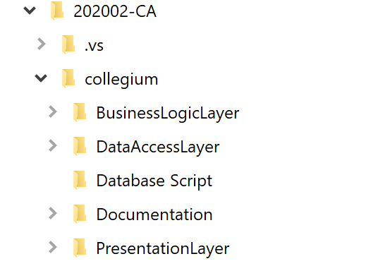

* BusinessLogicLayer holds the source code for the business logic of the application and its classes:
  + Entities: holds the main classes to be used on the system.
    - Student – main class for the object Student.
    - Log – main class for the object Log.
    - User – main class for the object User.
  + GeneralTools – holds the classes that interact with the system.
    - LoggedInDetails – manages the login information and state.
    - XmlTools – export the students as xml file.
      * ValidationTool – generic functions to manage the error provider inside the forms.
    - GeneralTools - generic message boxes functions and it sets the behaver on text boxes event: enter and leave.
* DataAccessLayer – holds the classes that gets/sets data over the database.
  + RepositoryBase – Parent classes for repositories below.
  + LogRepository – reads data from the table dbo.Logs.
  + StudentRepository – reads and writes data on the table dbo.Students.
  + UserRepository – reads and writes data on dbo.Users.
* PresentationLayer – holds the forms for the user interactions.
  + Login
    - FormLogin – Login form.
  + Students
    - FormDeleteStudent – delete students by student number.
    - FormNewStudent – add new student.
    - FormUpdateStudent – update student by student number.
  + Users
    - FormDeleteUser – delete users.
    - FormNewUser – add new users.
  + FormhistoryLog – shows the log of what happens over the system.
  + FormMain – main form, which also holds the main menu.
* Database Script – holds the file that creates the tables, procedure and example data.
* Documentation – holds the files that helped to create this document.

## Extras implementations

* Object oriented programming concepts to reduce the amount of code.
* Create and delete users from the database.
* Using SHA2 512 encrypting for passwords + salt.
* Use of delegates.
* Regex to validate fields.
* Storage procedure to capture logs.
* If Delete is pressed on the student grid it will call the function to delete student after confirmation is given.
* Double-click on the student grids bring the row select to edit form to update student information.
* Log from login attempts, even when fails.
* Error provider to validate empty field, incorrect email and so on.
* Status bar to control at the bottom of the app.
  + User that is logged in.
  + Name of the form that is active.
  + Date and time.

## Lessons Learned

I was able to apply the various concepts learned so far, but above all, multitier architecture was the most important topic for me, since it is how the market works and have this knowledge will improve my coding skills.

I was funny to have my app talk to dynamic libraries that I made, at the beginning it sounded extremely difficult, but as the app grew it became more friendly, not just the concept but how to code like that too.

## Difficulties

Working in a local database file did not sound difficult, however visual studio behaviour is not natural to work like that, although it works fine in database server using database name(catalog), ip, username and password, for a local file sometimes visual studio seems me to get confused by the file location, few times visual studio moved a copy of the database to debug/bin and data was lost by this action, eventually I decided to move the database file to debug/bin and pointing App.config to there as well, so it became stable enough to finish the project.

# Section 2 - Diagrams

During this project I used three different type of application to build the UML diagram, I decided to do that in order to practice different tools.

Sequence diagram I used the website <https://sequencediagram.org/> to be able to create a diagram from text, it was an interesting idea for me and I enjoyed doing that.

Inside the folder Documentation/Diagrams you will find the original file for each tool that I used, like the text files for the website above and visual paradigm file.

Diagrams are attached below.

## Use case

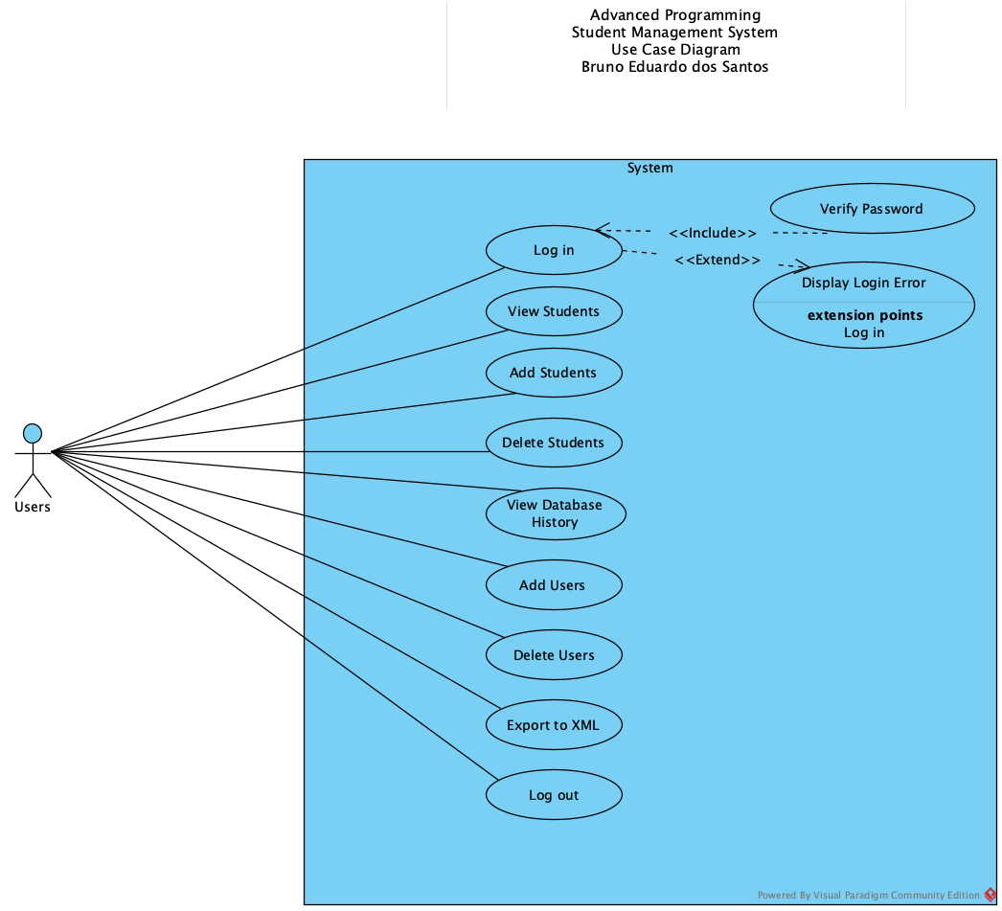

## Class Diagram

### Presentation Layer

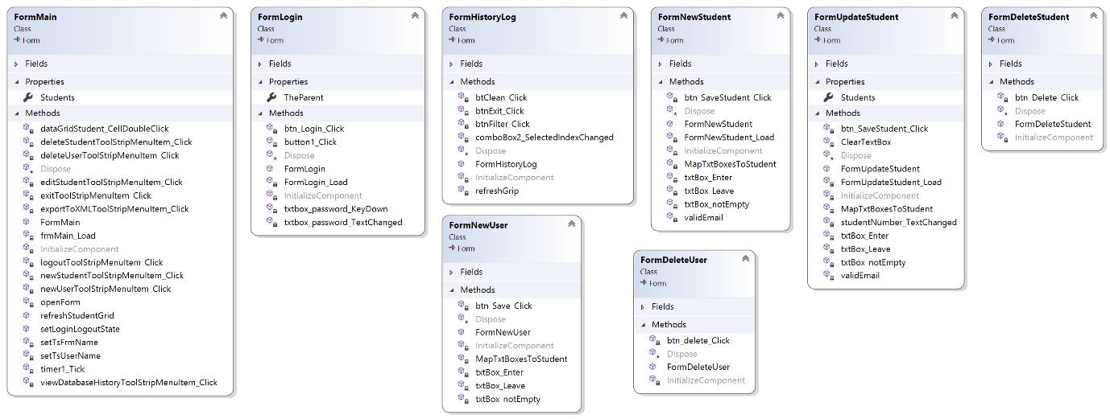

### Data Access Layer

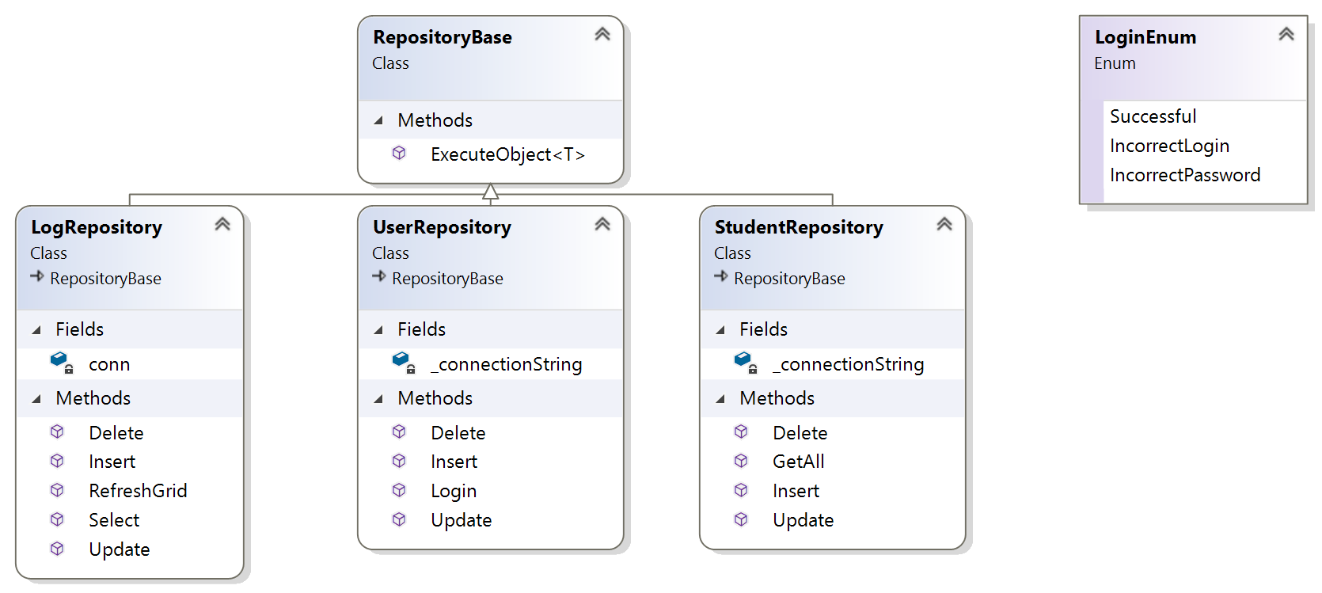

### Business Logic Layer

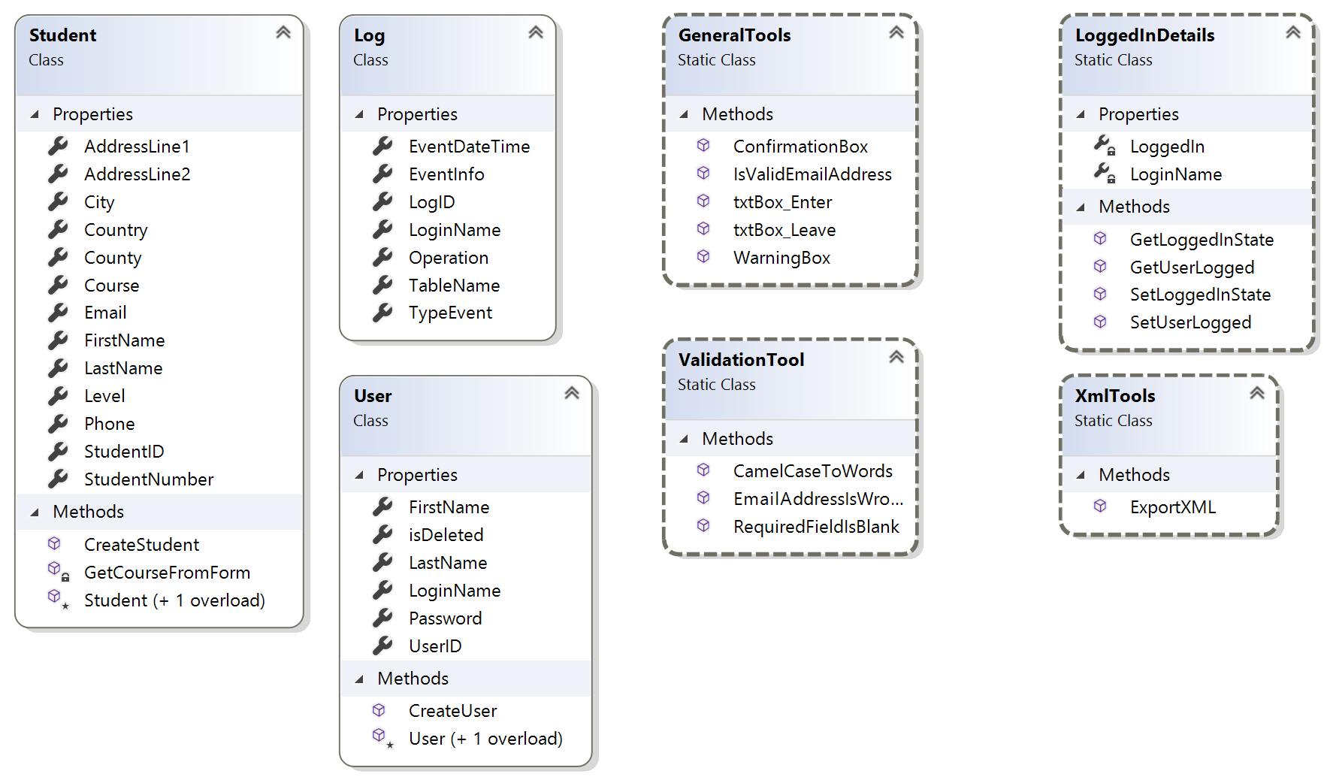

## Sequence Diagram

### Insert Student

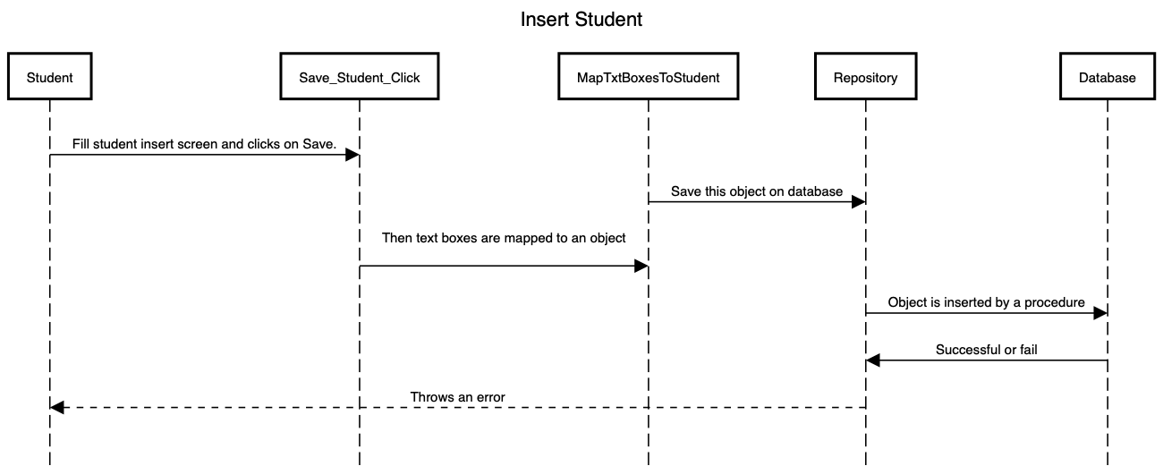

### Delete Student

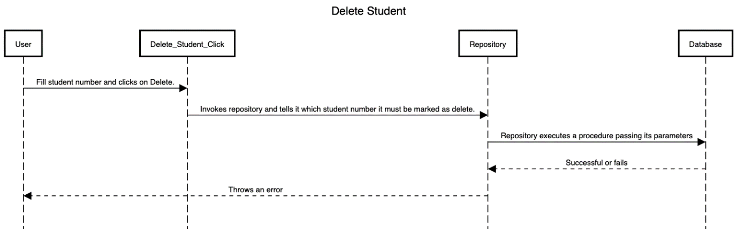

### Update Student

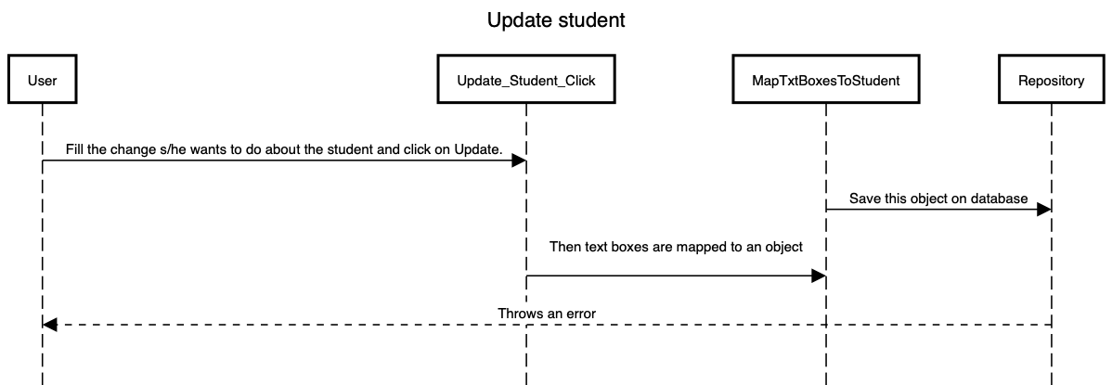

### Insert User

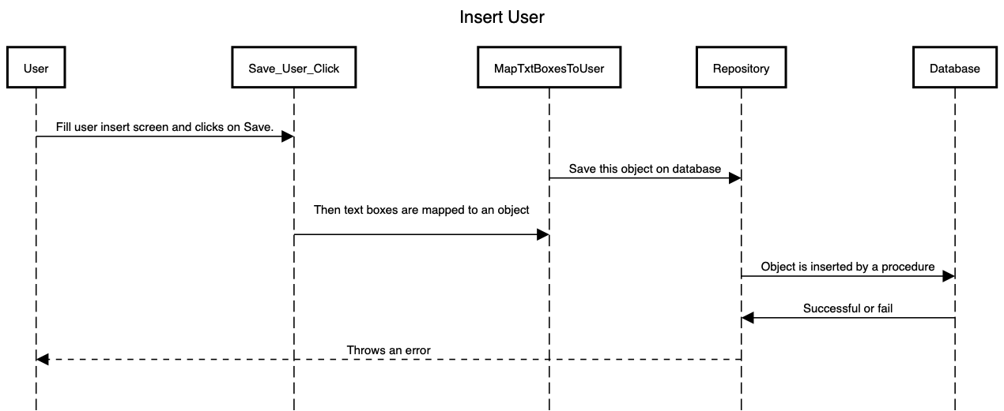

### Delete User

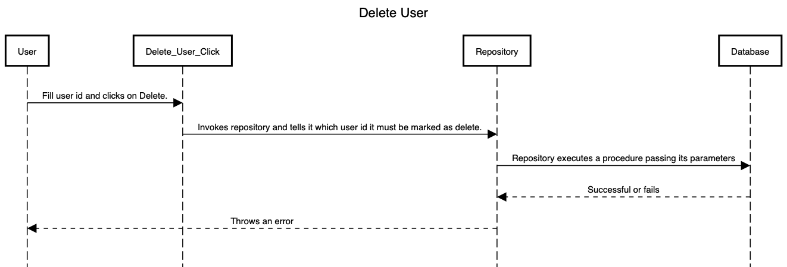

### Student Grid

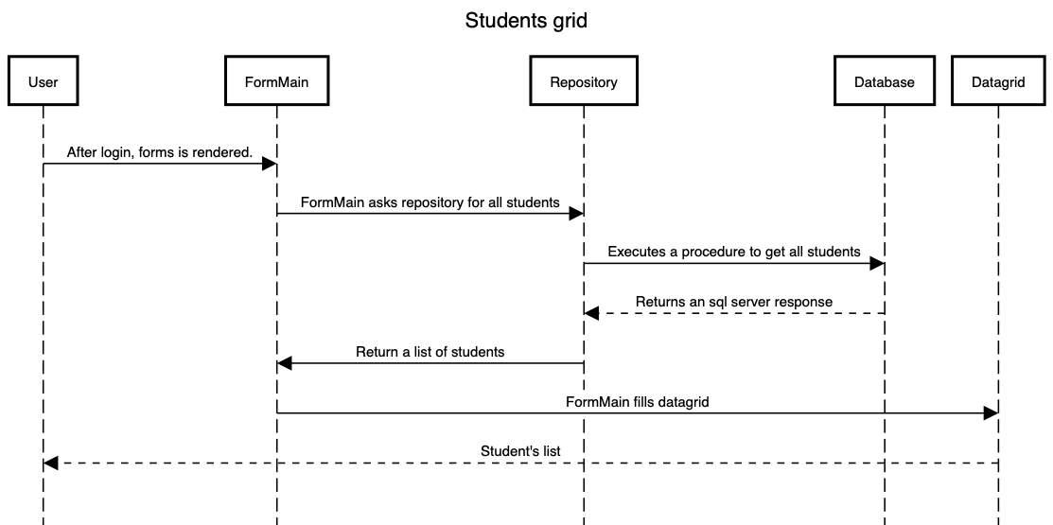

# Section 3 - Database Script

This is the file used to create the database and its objects. A copy of this file can also be found in Database script folder.

